Project documentation

1. Introduction:

* Project Title-InsightStream:Navigate the News Landscape
* Team ID-NM2025TMID3759
* Team Leader- DIVYASRI S /

Mail Id- [srisdivya7@gamil.com](mailto:srisdivya7@gamil.com)

* Team Member- ISWARYA V  [kuttyishu480@gmail.com](mailto:%20%20%20%20%20kuttyishu480@gmail.com)
* Team Member-KALPANA A

[Kalpanaanadhan07@gmail.com](mailto:Kalpanaanadhan07@gmail.com)

* Team Member-HARINI SHREE A

[harinishree2327@gmail.com](mailto:harinishree2327@gmail.com)

2.project overview:

* *News Insights is an innovative web application designed for users to explore, organize, and create news. It caters to both beginner and professional insights, providing an intuitive user experience and a vast collection of news insights.*
* Insight Stream automatically creates a live news feed of personalized search insights and important KPIs so you can focus on what's important without digging through data. Insight Stream proactively serves the most relevant information so you can take immediate action on recommendations and drive meaningful results.

3.features

·**News API Integration** – Fetches meals from the MealsDB API.

·**Visual Recipe Browsing** – Image-based navigation of categories.

·**Search Functionality** – Easily find recipes using keywords.

·**Interactive UI** – Built using modern design principles for a smooth experience.

Insight Stream automatically creates a live news feed of personalized search insights and important KPIs so you can focus on what's important without digging through data. Insight Stream proactively serves the most relevant information so you can take immediate action on recommendations and drive meaningful results.

**4.what are the key features of streams?**

What are the characteristics of a stream? Streams flow downhill due to gravity and the topography defines the direction of flow, as they follow the path of least resistance, through cracks. Small streams, springs and run-off come together to form

larger streams.

Insights influence the decision-making process. They are the foundation on which strategies are built, and they help to

optimise and improve business operations.

**5. 8 Benefits of Insight Discovery**

* Improving Communication Skills. Insight Discovery provides a valuable platform for individuals to enhance their communication abilities. ...
* Enhanced Leadership and Decision-Making. ...
* Conflict Resolution and Relationship Building. ...
* Applying Insight Discovery in Your Organisation.

**ARCHITECTURE:**

**Component Structure**

Streaming Data Architecture in 2023: Components & Examples ...An architecture insight stream describes the practical understanding of design principles, spatial qualities, and functional and aesthetic considerations that inform the creation of buildings and environments. This stream encompasses visual imagination, an understanding of the environment and topography, awareness of building history, and knowledge of various architectural styles like classical, contemporary, and industrial. Architects develop this insight by studying design, observing existing structures, and hands-on experience, enabling them to infuse buildings with personality and foster a connection with people.

Key Aspects of an Architecture Insight Stream:

Visual Imagination:

The ability to mentally visualize and manipulate spaces, which helps in designing innovative and suitable solutions from scratch.

Environmental Awareness:

Understanding how buildings interact with their surroundings, considering topography, water features, roads, and other existing structures.

Aesthetic Sensibility:

The capacity to create visually appealing and harmonious buildings that serve expressive purposes.

Functional Design:

Ensuring that buildings fulfill practical requirements while also being aesthetically pleasing.

Understanding of Styles:

Knowledge of various architectural styles, such as classical, contemporary, neoclassical, and industrial.

Contextual Integration:

The art of creating structures that possess a distinctive personality and blend well with their environment.

**How Architects Develop This Insight:**

**Formal Education:**

Studying the principles of architecture, which is the art and technique of designing and building.

**Software and Technology**:

Utilizing design software to realize designs, but always beginning with a conceptual visualization of the space.

Observation and Experience:

Exploring buildings, observing how spaces create different atmospheres, and learning from the real world.

**Creative Problem-Solving:**

Adding innovative ideas and elements to designs, which is an integral part of the architectural process.

The application is divided into three main sections:

* **Pages** – Full-page components (Home, News Category, News Details).
* **Components** – Reusable UI elements (Navbar, Search Bar, News Cards, Category Filter).
* **Styles** – CSS and styling files (Global styles, Component-specific styles).

6.Source code:

import React from 'react'

import '../styles/Footer.css'

import { useNavigate } from 'react-router-dom';

const Footer = () => {

const navigate = useNavigate();

return (

<footer>

<div className='footer'>

<ul>

<li onClick={()=> navigate("/category/")} >General</li>

<li onClick={()=> navigate("/category/Technology")} >Technology</li>

<li onClick={()=> navigate("/category/Science")} >Science</li>

</ul>

<ul>

<li onClick={()=> navigate("/category/Lifestyle")} >Lifestyle</li>

<li onClick={()=> navigate("/category/Health")} >Health</li>

<li onClick={()=> navigate("/category/Fitness")} >Fitness</li>

</ul>

<ul>

<li onClick={()=> navigate("/category/Business")} >Business</li>

<li onClick={()=> navigate("/category/Stock Markets")} >Stock Markets</li>

<li onClick={()=> navigate("/category/Exchanges")} >Exchanges</li>

</ul>

<ul>

<li onClick={()=> navigate("/category/Geo-Politics")} >Geo-Politics</li>

<li onClick={()=> navigate("/category/Wars")} >Wars</li>

<li onClick={()=> navigate("/category/Current-Affairs")} >Current Affairs</li>

</ul>

</div>

<hr />

<p>SB news - &copy; 2023 - All rights reserved</p>

</footer>

)

}

export default Footer

7.OUTPUT SCREENSHOT

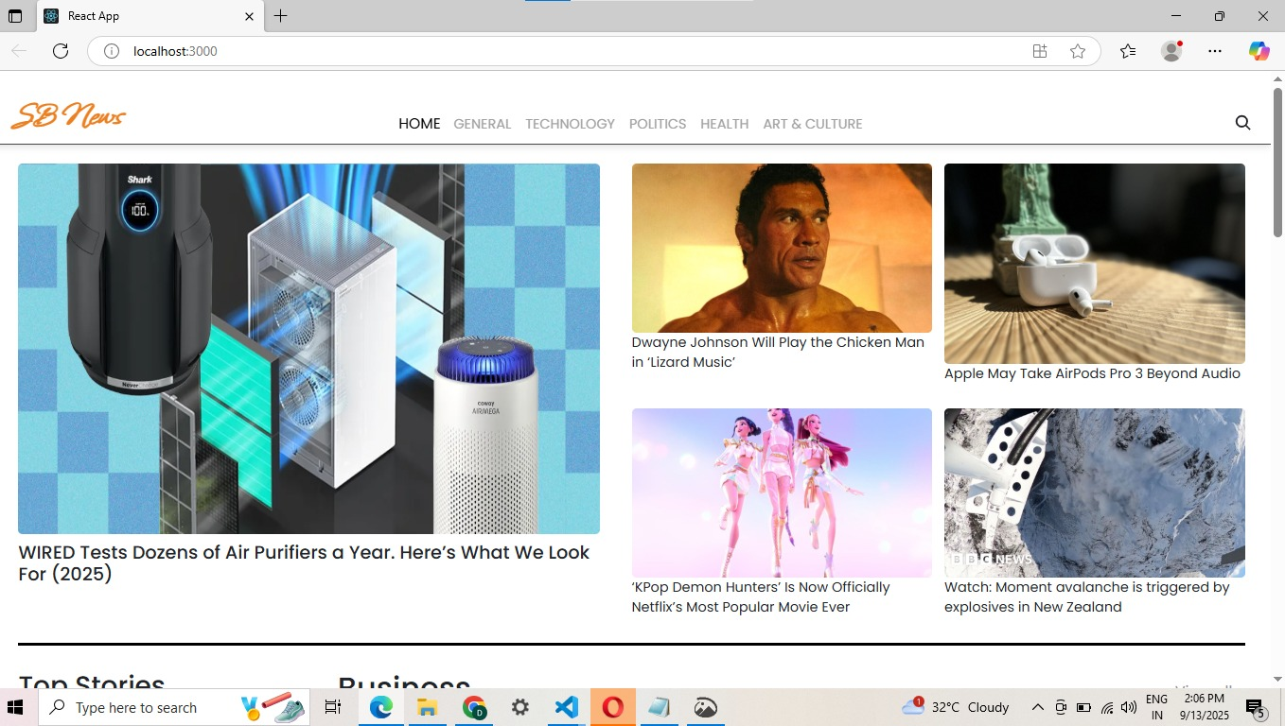

8.DEMO LINK

<https://drive.google.com/drive/folders/1TrRcYndS9dJZCsu9bLgx0Z9mxR_Kp1m1>

***Thank You***